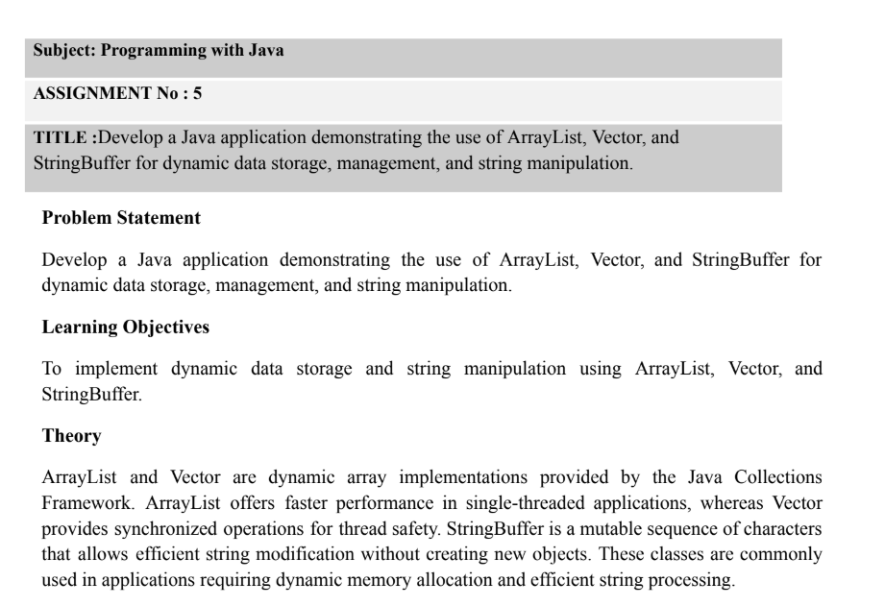

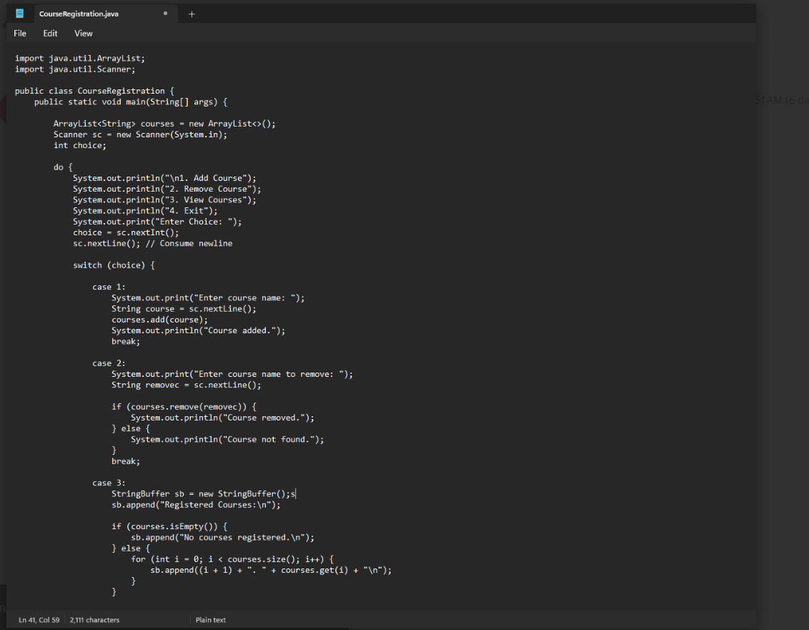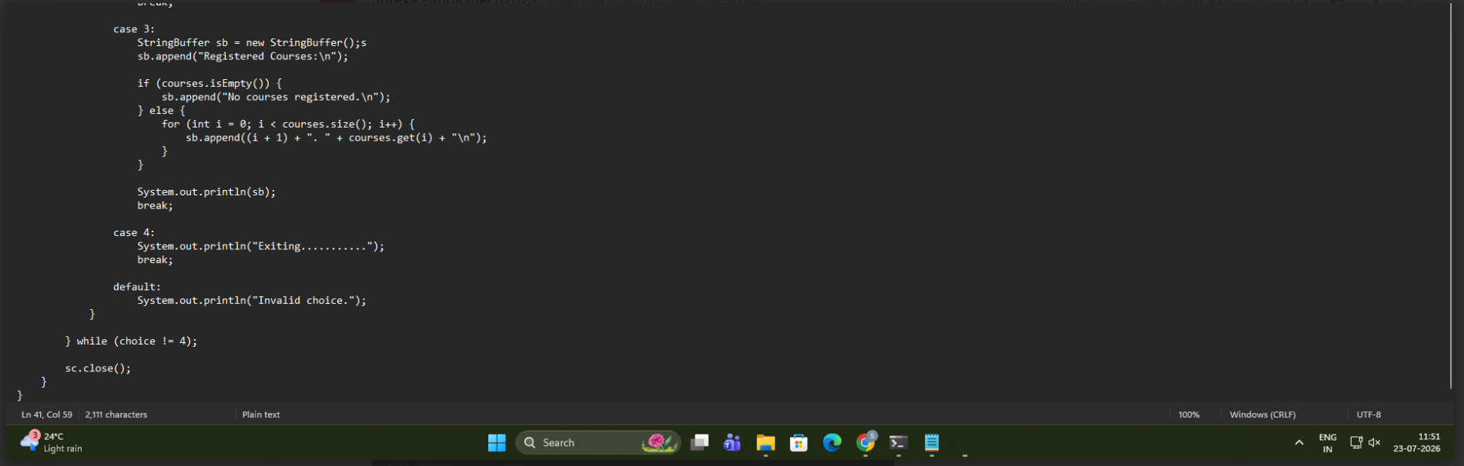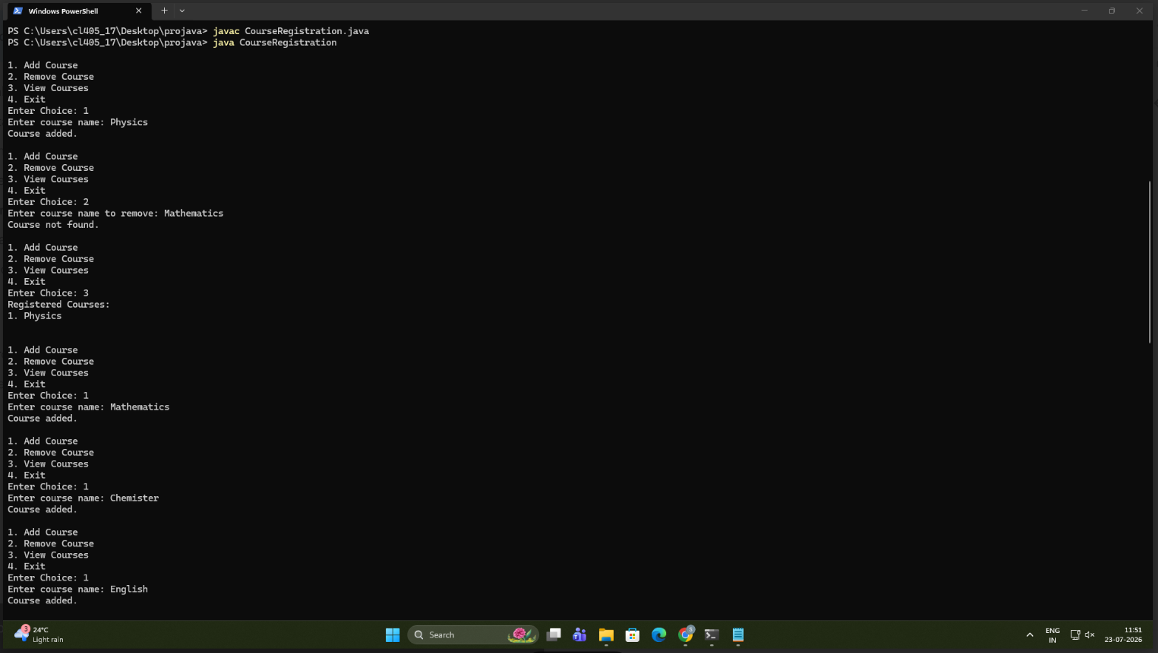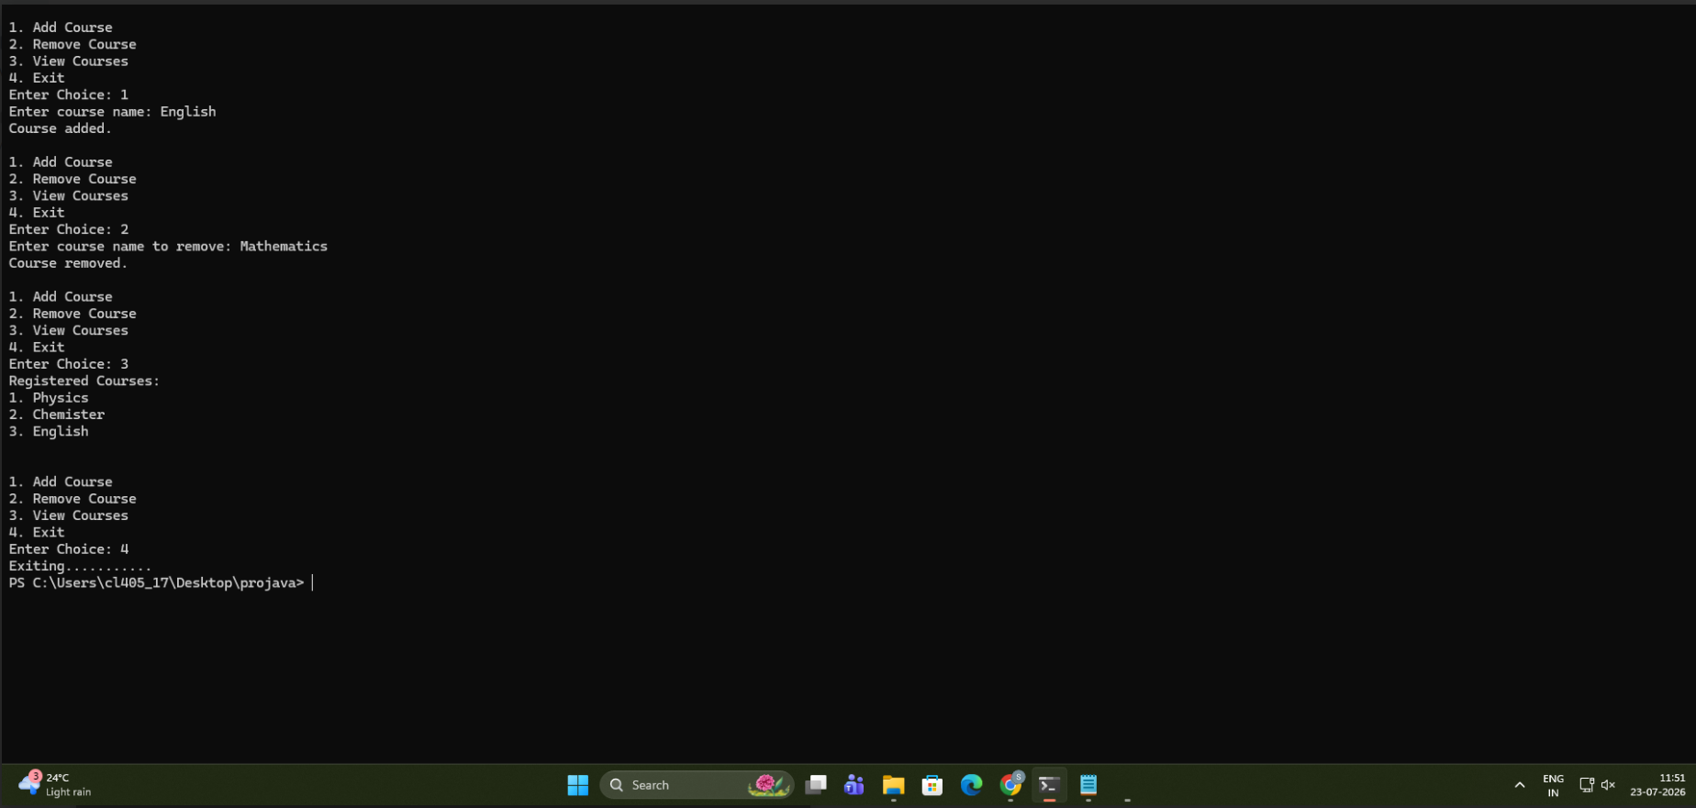
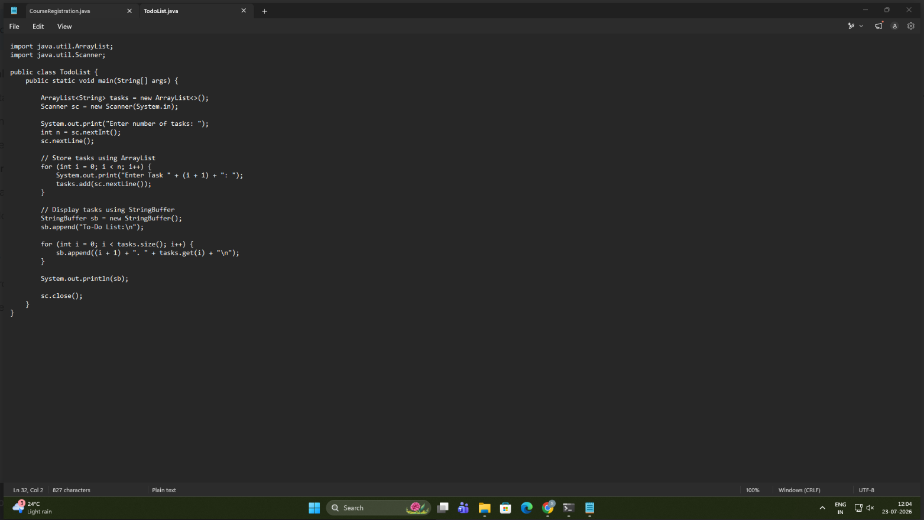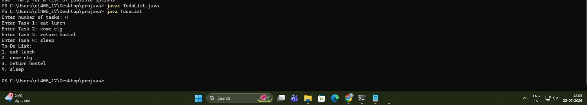
Conclusion
This assignment helped in understanding the use of ArrayList, Vector, and StringBuffer in Java. It demonstrated how ArrayList and Vector can be used for dynamic data storage and management, while StringBuffer enables efficient string modification. The program improved understanding of Java Collection Framework concepts and highlighted the differences and practical applications of these classes in Java programming.

